Doctors Assistant Program Continued
New Mexico
Supercomputing Challenge
Final Report
April 8, 2020

Team # 70
Taos High School
Team Members
Haven Hennelly
James Ryan Cox
Sawyer Solfest
Skylar Spriggs
Teacher(s)
Tracy Galligan
Project Mentors
N/A

Table of Contents
__________________________________________________________
- Executive Summary 3

- Problem Statement 4

- Methods 4

- Verification and Validation of Model 5

- Results 6

- Conclusions 7

- Software, References and Tables 7

- Most Significant Achievement 10

- Acknowledgments 11

Executive Summary
This year, the team continued a project started last year called the Doctor’s Assistant Program. The program’s goal was to provide an initial prediction of an ailment that the patient had based on symptom information gathered through natural conversation. This program would then send the data to a doctor, who could consult the symptoms and give a more accurate diagnosis if needed. The program continues to use yes and no questions to gather a collection of responses to produce a diagnosis. If the patient exhibits multiple symptoms relating to a specific ailment, the program will inform the doctor the program’s predicted ailment.
This year, the team created a functioning and expandable database attached to a UI. The purpose of the database was to increase the functionality and scope of the Doctor’s Assistant Program. These additions furthered the development of the program.

Problem Statement
In the medical fields, misdiagnosis is an ongoing issue especially during pandemics. Even though misdiagnosis has been an issue for years, in 2020 inaccuracy can be disastrous. The outbreak of COVID-19 has made it even more imperative that medical professionals are as precise as possible. Medical emergencies cause doctors to spread thin, decreasing precision. A few years ago, the Washington Post wrote “[m]ore than 20 percent of patients who sought a second opinion at one of the nation’s premier medical institutions had been misdiagnosed by their primary care providers, according to new research published” (Bernstein, Lenny). Now more than ever, precise diagnoses can be the difference between containing a disease or spreading it to more people, whether in a pandemic or not. The rates below represent America’s diagnosis rates in 2017 (Fig.1).]
Method
The team continued this project from last year, in which we addressed the problem of medical misdiagnoses by building a simple program to diagnose illnesses. This first version of the program was very limited in scope. It could diagnose only five illnesses based on a set of basic nested if/else loops. This system, while easy to write and deploy, was inefficient and inextensible. This year, to address these issues, the team completely rewrote the program by creating a diagnosis engine which ran on a server-client model. Diagnosis data was stored in a fully extensible SQL database that could be easily and efficiently updated and reorganized. The diagnosis engine was reengineered with more flexibility. Both the engine and client application were written in Python 3.8.1. The server was built using python and MySQL Community 2019 on an Ubuntu 18.04 LTS server.
The purpose of the UI was to give the program a proper interface that is user friendly and doesn’t run from the command window. The UI wasn’t nearly as important as the database. But for those interested the UI was made in the Python module Kivy. Kivy uses .kv files to define the pieces of the UI: buttons, text boxes, inputs, etc. Using these files, Kivy builds a interface for the user, connecting the user to the software for patient and doctor use.
One important element of the project was the supporting medical information and data. Information about diseases and symptoms stored within the program are sourced from the Mayo Clinic, the US National Library of Medicine, Harvard Health, The CDC and Oxford Medicine Online. Although our production of algorithms was halted, the plan remains. Our plan would have used highly coveted sanitized medical records to create algorithms. An example of our research would be our knowledge on hyperlipidemia provided by the mayo clinic, which states that hyperlipidemia “has no symptoms. A blood test is the only way to detect if you have it” (High cholesterol), 2019, July 13.

Verifying Models
Due to the sensitive nature of medical information, the team was unable to test their model in a clinical environment. The team made plans to search for professional assistance, but the pandemic of COVID-19 set professionals' eyes on more important matters. In limited hypothetical testing, results from the program were consistent with both publicly available anonymous medical records and anecdotal evidence.
The team started by creating a patient that experienced a scratchy throat, swollen tonsils, and difficulty swallowing. The program predicted the patient had a sore throat, likely suffering from Acute Laryngopharyngitis. The team saw this to match up three of the seven symptoms in the database “pain or a scratchy sensation in the throat, pain that worsens with swallowing or talking, difficulty swallowing, sore, swollen glands in your neck or jaw, swollen, red tonsils, white patches or pus on your tonsils, a hoarse or muffled voice” (Mayo Clinic, 2020).
The team then wished to try an entirely different ailment. The patient had a constant urge to use the bathroom, a burning sensation while urinating, and cloudy urine that had a strong smell. The database matched with four of the six symptoms of Urinary Tract Infection in males, seven in females (Harber, 2020), making UTI a likely ailment.
The team wanted to then give the program a more difficult case to diagnose. This hypothetical patient experienced a runny nose, a sore throat, and a postnasal drip. These symptoms meet similar criteria to Hay Fever, and Acute Sinusitis. The difference between these two ailments is coughing, which the patient did not experience. This means the patient shows a higher chance of Acute Sinusitis. The program detected that the patient did not experience coughing and diagnosed the patient with Acute Sinusitis.

Results
The program can take in basic inputs and can diagnose a patient as an output. However, this is not the full function of the program. Due to the outbreak of COVID 19, the program’s development was stunted. The system provided information that were consistent with expectations while maintaining acceptable stability within a limited testing environment. The program got rewritten and updated to work with GitHub but wasn’t finished due to the pandemic.

Conclusions
The new version of the Doctor’s Assistant Program allows for a much broader scope of diagnosing through a constant expansion of the database. This addition allows the program to be applied to multiple fields of medicine like epidemiology and the treating of physical injuries. By expanding to different medicinal fields, the program could have a positive impact on misdiagnosis rates in multifarious fields of medicine. With the new addition the Doctor’s Assistant Program has come much closer to affecting the overall misdiagnosis rate.

Software, References, Tables, and Other Products
Fig. 1-2 – The 2017 misdiagnosis rates
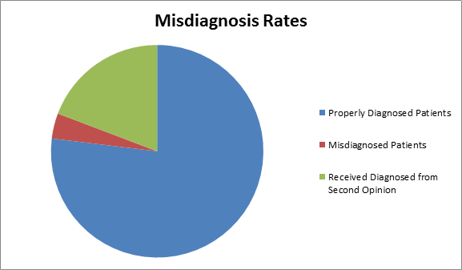Fig 1.

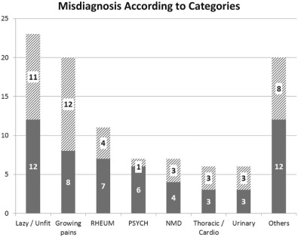Fig 2.

Fig. 3 – SQl Server
Fig 3.

Fig. 4 – The UI
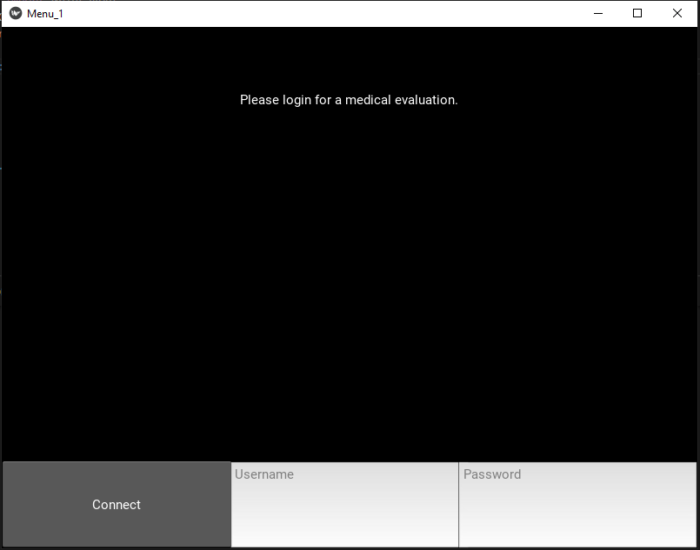Fig 4.

Fig.5-6 – The end user client
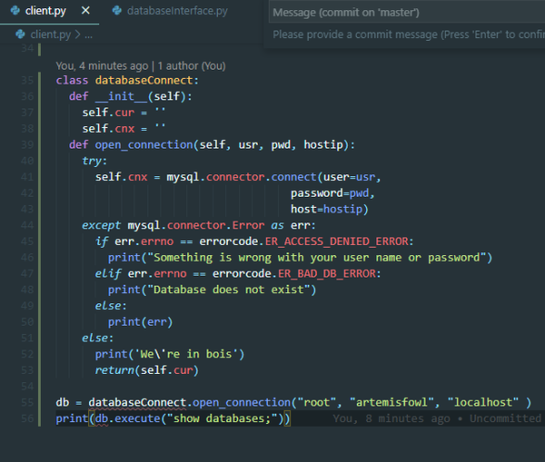Fig 5.
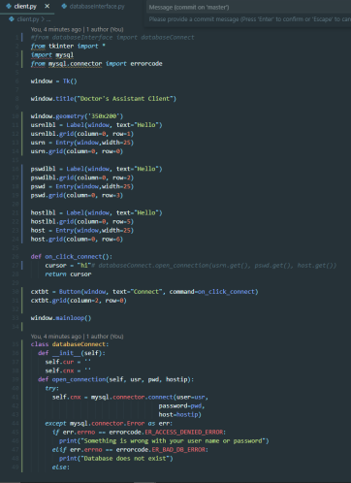Fig 6.

Most Significant Achievement
The most significant achievement is currently holding the team together during the COVID-19 pandemic. It became difficult to communicate effectively, so the team went to great measures to keep priorities straight. An allegorical representation of our experience would be repairing a submarine with scotch tape. This allowed for the team to work on specific parts of the program and report from a distance, also maintaining social distancing. The team continued to keep up to date on the program, allowing us to stay on track.

Acknowledgments
The team would like to thank their teacher Tracy Galligan for encouraging them to persevere through this confusing time. Especially during the COVID-19 outbreak, the team gained some much-needed guidance. The team thanks her for the effort she put in to organizing everyone’s participation and focuses for this year.

Works Cited:
Bernstein, L. (2017, April 04). 20 percent of patients with serious conditions are first
misdiagnosed, study says. Retrieved April 02, 2019, from https://www.washingtonpost.com/national/health-science/20-percent-of-patients-with-serious-conditions-are-first-misdiagnosed-study-says/2017/04/03/e386982a-189f-11e7-9887-1a5314b56a08_story.html?noredirect=on&utm_term=.c0f17a0a371f
Data for the diagnosis model:
Hypertension:
High blood pressure (hypertension). (2018, May 12). Retrieved from https://www.mayoclinic.org/diseases-conditions/high-blood-pressure/symptoms-causes/syc-2037341
Hyperlipidemia:
Bridger, H. (2017, August 30). Beyond Cholesterol. Retrieved from https://hms.harvard.edu/news/beyond-cholesterol
High cholesterol. (2019, July 13). Retrieved from https://www.mayoclinic.org/diseases-conditions/high-blood-cholesterol/symptoms-causes/syc-20350800
Diabetes:
Diabetes | Type 1 Diabetes | Type 2 Diabetes. (2020, March 24). Retrieved from https://medlineplus.gov/diabetes.html
Back Pain:
Harvard Health Publishing. (n.d.). Back Pain. Retrieved from https://www.health.harvard.edu/topics/back-pain
Anxiety:
Morrough, J. W., Yaqbui, S., Sayed, S., & Charney, D. S. (2015). Emerging Drugs for the Treatment of Anxiety. Expert Opin Emerg Drugs. Retrieved from https://www.ncbi.nlm.nih.gov/pmc/articles/PMC4869976/
Obesity:
Obesity. (2020, February 15). Retrieved from https://www.mayoclinic.org/diseases-conditions/obesity/symptoms-causes/syc-20375742
Allergic rhinitis:
Hay fever. (2019, March 19). Retrieved from https://www.mayoclinic.org/diseases-conditions/hay-fever/symptoms-causes/syc-20373039
Reflux esophagitis:
Harvard Health Publishing. (n.d.). Esophagitis. Retrieved from https://www.health.harvard.edu/a_to_z/esophagitis-a-to-z
Hypothyroidism:
Hypothyroidism (underactive thyroid). (2020, January 7). Retrieved from https://www.mayoclinic.org/diseases-conditions/hypothyroidism/symptoms-causes/syc-20350284
Fibromyalgia:
Fibromyalgia. (2017, October 11). Retrieved from https://www.cdc.gov/arthritis/basics/fibromyalgia.htm
Malaise and fatigue:
Harvard Health Publishing. (n.d.). When should you worry about fatigue? Retrieved from https://www.health.harvard.edu/staying-healthy/when-should-you-worry-about-fatigue
Symptoms of ME/CFS. (2019, November 19). Retrieved from https://www.cdc.gov/me-cfs/symptoms-diagnosis/symptoms.html
Acute Laryngopharyngitis:
Sore throat. (2020, February 1). Retrieved from https://www.mayoclinic.org/diseases-conditions/sore-throat/symptoms-causes/syc-20351635
Acute maxillary sinusitis:
Harvard Health Publishing. (n.d.). Acute Sinusitis. Retrieved from https://www.health.harvard.edu/a_to_z/acute-sinusitis-a-to-z
Major depressive disorder:
Depression (major depressive disorder). (2018, February 3). Retrieved from https://www.mayoclinic.org/diseases-conditions/depression/symptoms-causes/syc-20356007
Feltes, P. K., Doorduin, J., Klein, H. C., Juárez-Orozco, L. E., Dierckx, R. A., Moriguchi-Jeckel, C. M., & Vries, E. F. D. (2017). Anti-inflammatory treatment for major depressive disorder: implications for patients with an elevated immune profile and non-responders to standard antidepressant therapy. Journal of Psychopharmacology, 31(9), 1149–1165. doi: 10.1177/0269881117711708
Acute Bronchitis:
Sahetya, S. (2016). Acute Uncomplicated Bronchitis. Oxford Medicine Online. doi: 10.1093/med/9780199976805.003.0029
Asthma:
Asthma. (2018, September 13). Retrieved from https://www.mayoclinic.org/diseases-conditions/asthma/symptoms-causes/syc-20369653
Toenail fungus:
Harvard Health Publishing. (n.d.). Staying one step ahead of toenail fungus. Retrieved from https://www.health.harvard.edu/diseases-and-conditions/staying-one-step-ahead-of-toenail-fungus
Nail fungus. (2019, January 3). Retrieved from https://www.mayoclinic.org/diseases-conditions/nail-fungus/symptoms-causes/syc-20353294
Coronary atherosclerosis:
Arteriosclerosis / atherosclerosis. (2018, April 24). Retrieved from https://www.mayoclinic.org/diseases-conditions/arteriosclerosis-atherosclerosis/symptoms-causes/syc-20350569
Silva, D. A. D., Woon, F.-P., Lee, M.-P., Chen, C. L.-H., Chang, H.-M., & Wong, M.-C. (2009). Metabolic Syndrome Is Associated with Intracranial Large Artery Disease among Ethnic Chinese Patients with Stroke. Journal of Stroke and Cerebrovascular Diseases, 18(6), 424–427. doi: 10.1016/j.jstrokecerebrovasdis.2009.01.010
Urinary tract infection:
Harber, M. (2015). Upper urinary tract infection. Oxford Medicine Online. doi: 10.1093/med/9780199592548.003.0177

